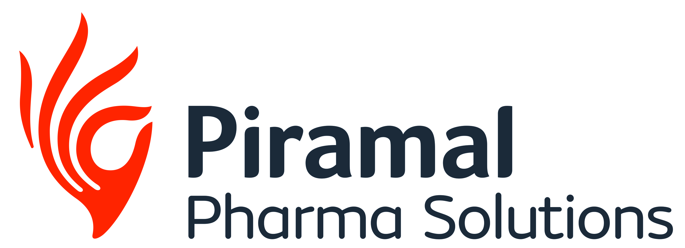

PRESS RELEASE
Piramal Pharma Solutions Unveils State-of-the-Art Payload-Linker
Suite at its Riverview, Michigan Facility
- The Riverview facility provides comprehensive services for active pharmaceutical ingredients (APIs) and high potency APIs (HPAPIs), including specialized solutions for payload-linkers.
- Piramal Pharma Solutions added this cutting-edge suite to the site to support global payload-linker development and manufacturing.
- This will significantly enhance the company’s ability to help partners bring complex therapies like antibody-drug conjugates (ADCs) and other bioconjugates to market.
Mumbai, India | May X, 2026: Piramal Pharma Solutions, a leading global Contract Development and Manufacturing Organization (CDMO) and part of Piramal Pharma Ltd. (NSE: PPLPHARMA | BSE: 543635) (“PPS”), has officially unveiled a new, state-of-the-art payload-linker development and manufacturing suite at its Riverview, Michigan drug substance facility. This launch is a key element of the company's broader $90 million investment plan to extend U.S.-based manufacturing capabilities, announced last year. In addition to the payload-linker suite, the plan will add new technology and enhanced commercial-scale manufacturing capabilities at PPS’s dedicated sterile injectables facility in Lexington, Kentucky. These strategic enhancements reinforce PPS’s commitment to bringing complex and innovative therapies to patients quickly and reliably.
To commemorate this unveiling, a ribbon-cutting ceremony was attended by site staff, industry partners, and PPS leadership – including Nandini Piramal, Chairperson of Piramal Pharma Limited and Peter DeYoung, CEO of Piramal Global Pharma – who highlighted the positive economic and scientific impact of the expansion.
“The launch of our new payload-linker suite at Riverview marks a major milestone for PPS and our partners,” said Peter DeYoung. “The suite places world-class expertise, advanced technology, and commercial-scale payload-linker capabilities right here in Michigan, empowering our customers to accelerate the development and delivery of life-changing therapies, like ADCs. This investment demonstrates our deep commitment to U.S.-based innovation and manufacturing, ensuring our partners benefit from unmatched efficiency, supply chain security, and a seamless path from concept to clinic for these critical medicines.”
With over 60 years of drug substance development and manufacturing experience, Riverview is a distinguished leader in its field. Drawing on its diverse expertise, the site provides a comprehensive range of capabilities for APIs and HPAPIs. Leveraging its specialized HPAPI knowledge and abilities, Riverview serves as PPS’s dedicated payload-linker supplier, making it critical to ADCelerate™ – PPS’s rapid, integrated approach to phase I ADC development.
The addition of this payload-linker suite is designed to help PPS accelerate partners’ timelines and adapt to evolving market needs. Equipped with advanced containment, automation, and analytical technologies, the suite enables seamless scaling of payload-linker programs. This further strengthens the ADCelerate™ platform and positions PPS to meet the rising demand for ADCs and other bioconjugate therapies.
The expansions in Riverview and Lexington reinforce PPS’s position as the partner of choice for innovator companies looking for patient-centric, U.S.-based drug development and manufacturing solutions.
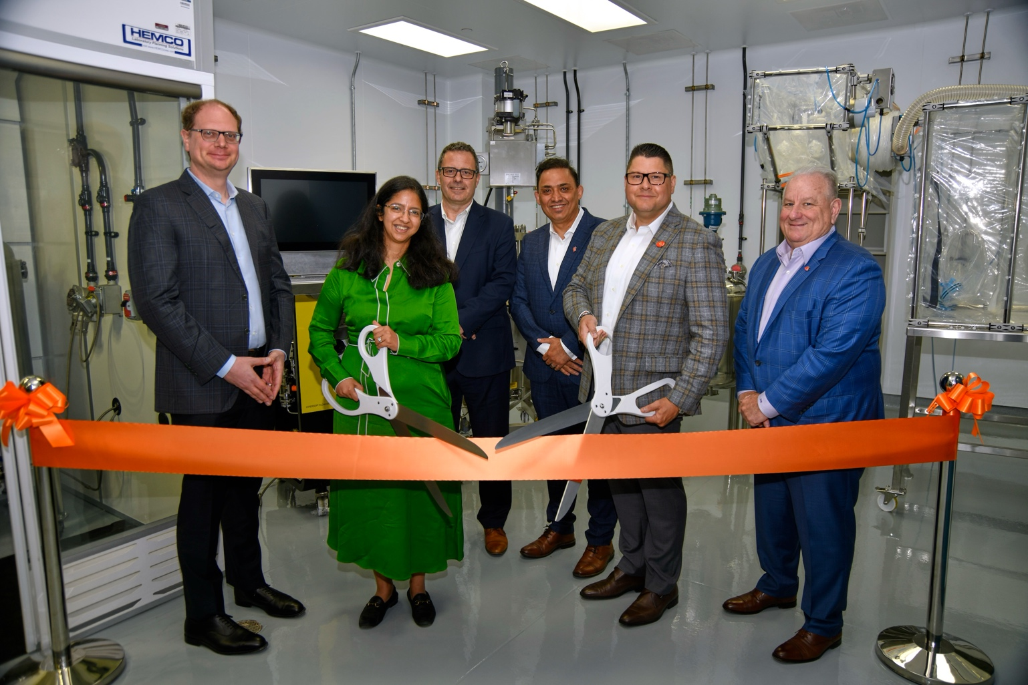
Ribbon cutting at Piramal Pharma Solutions’ payload-linker suite, Riverview, MI.
Left to right: Peter DeYoung, CEO; Nandini Piramal, Chairperson; Herve Berdou, COO; Manoj Zalpuri, EVP North America Operations; Bruce Guimares, VP & Site Head; Stu Needleman, CCO.
About Piramal Pharma Solutions
Piramal Pharma Solutions (PPS) is a Contract Development and Manufacturing Organization (CDMO) offering end-to-end development and manufacturing solutions across the drug life cycle. We serve our customers through a globally integrated network of facilities in North America, Europe, and Asia. This enables us to offer a comprehensive range of services including drug discovery solutions, process and pharmaceutical development services, clinical trial supplies, commercial supply of APIs, and finished dosage forms. We also offer specialized services such as the development and manufacture of highly potent APIs, antibody-drug conjugations, sterile fill/finish, peptide products and services, and potent solid oral drug products. PPS also offers development and manufacturing services for biologics including vaccines and gene therapies, made possible through Piramal Pharma Limited’s associate company, Yapan Bio Private Limited.

For more information visit: Piramal Pharma Solutions | LinkedIn| Facebook | X

About Piramal Pharma Limited
Piramal Pharma Limited (PPL, NSE: PPLPHARMA I BSE: 543635), offers a portfolio of differentiated products and services through its 17* global development and manufacturing facilities and a global distribution network in over 100 countries. PPL includes Piramal Pharma Solutions (PPS), an integrated contract development and manufacturing organization; Piramal Critical Care (PCC), a complex hospital generics business; and the Piramal Consumer Healthcare business, selling over-the-counter consumer and wellness products. In addition, one of PPL's associate companies, Abbvie Therapeutics India Private Limited, a joint venture between Abbvie and PPL, has emerged as one of the market leaders in the ophthalmology therapy area in the Indian pharma market. Further, PPL has a strategic minority investment in Yapan Bio Private Limited, that operates in the biologics / bio-therapeutics and vaccine segments.

For more information, visit: Piramal Pharma | LinkedIn
For Investor Queries:  Gagan Borana  Investor Relations & Enterprise Risk Management  gagan.borana@piramal.com | For Media Queries:  Madiha Vahid  Lead – Branding & Communications  madiha.vahid@piramal.com
* Includes one facility via PPL’s minority investment in Yapan Bio.

